

**Explore Linate today**

**Now support Long-Term Version**

**Main features:**

* *Milano Linate with solid HD buildings, A.I. vehicles and true light markings.*
* *Overlay (3D building, roads, vegetables) covered over 2500 km2*
* *Orthophotos covered over 2500 km2*
* *Updated with new airport jetways and Visual Docking System*

**System requirements:**

*Minimum X-plane version:* **11.50+**

**Installation:**

* 1. *Extract all files and folders into your main X-plane folder.*
  2. *Go to “Custom Scenery” folder and open “scenery_packs.ini”*
  3. *Add these following lines onto the top of the file:*

*SCENERY_PACK Custom Scenery/a_TFSD_Linate/*

*Add this line under the line “Global Airports”:*

*SCENERY_PACK Custom Scenery/h_TFSD_Linate_Overlays/*

*Add this line at the end of the file:*

*SCENERY_PACK Custom Scenery/z_TFSD_Linate_Orthophotos/*

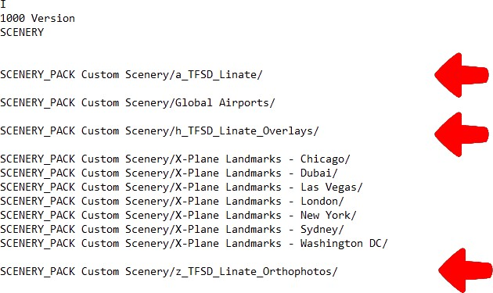

**Download links:**

[Part 1](https://modsfire.com/V6tjL6fncC034TB) and [Part 2](https://modsfire.com/V4LfJ7zAcW4l7iT). You also need [TFS Library](https://www.nexusmods.com/xplane11/mods/7) to make this product works properly.